**FOOD DELIVERY APPLICATION**

**A Mini-Project Report**

**Under**

**Project Workshop**

***Submitted by***

**RUDRA SHANKER(N029)**

**OJASHWI SENGAR(N027)**

**AMOGH SHETE(N032)**

***Under The Guidance Of***

**PROF. RATNESH CHATURVEDI**

***in partial fulfillmet for the award of the degree***

***of***

***MBATECH***

***In***

***Computer Science***

***At***



**MUKESH PATEL SCHOOL OF TECHNOLOGY MANAGEMENT &ENGINEERING, MUMBAI**

**APRIL, 2016**

**CERTIFICATE**

This is to certify that the project entitled **FOODZILLA** is the bonafide work carried out by RUDRA SHANKER, OJASHWI SENGAR, AMOGH SHETE MBATech (Computer Engineering), MPSTME (NMIMS), Mumbai, during the fourth semester of the academic year 2015-2016, in fulfillment of the requirements for the award of the Degree of MBATECH as per the norms prescribed by NMIMS. The project work has been assessed and found to be satisfactory.

___________________

PROF. RATNESH CHATURVEDI

Internal Mentor

_______________________ ________________________

Examiner 1 Examiner 2

________________________

Dean

Dr. Sharad Y. Mhaiskar

**DECLARATION**

We, RUDRA SHANKER , OJASHWI SENGAR, AMOGH SHETE MBATech (Computer Engineering), semester- IV, understand that plagiarism is defined as anyone or combination of the following:

1. Un-credited verbatim copying of individual sentences, paragraphs or illustration (such as graphs, diagrams, etc.) from any source, published or unpublished, including the internet.

2. Un-credited improper paraphrasing of pages paragraphs (changing a few words phrases, or rearranging the original sentence order)

3. Credited verbatim copying of a major portion of a paper (or thesis chapter) without clear delineation of who did wrote what.

4. We have made sure that all the ideas, expressions, graphs, diagrams, etc., that are not a result of our work, are properly credited. Long phrases or sentences that had to be used verbatim from published literature have been clearly identified using quotation marks.

5. We affirm that no portion of my work can be considered as plagiarism and we take full responsibility if such a complaint occurs. We understand fully well that the guide of the seminar/ seminar report may not be in a position to check for the possibility of such incidences of plagiarism in this body of work.

Signature of the Students:

___________ ____________ ___________ ____________

Name: ___________ ____________ ___________ ____________

Roll No. ___________ ____________ ___________ ____________

Place: Mumbai

Date: April 2016

**ACKNOWLEDGMENT**

I take this opportunity to express my sincere deference and gratitude to Prof. Ratnesh Chaturvedi for his constant guidance and motivation provided during the course of this work. It was a unique privilege to work under his valuable guidance and supervision. Also my H.O.D Dr. Dhirendra Mishra for encouraging me to perform the seminar work and Dean Dr. Sharad Y. Mhaiskar for providing such platform.

I also like to wish my immense gratitude to all the authors of the papers whose reference has made this presentation and report possible reality.

I convey my gratitude to all who’s directly or indirectly involvement and valuable suggestions helped me and hope for further inputs in the future.

I would also like to take this opportunity to thank MPSTME library, and resource for providing with all the research papers, data, archives and other reference in a timely manner.

**Table of contents**

**CHAPTER NO. TITLE PAGE NO.**

List of Figures 6

Abbreviations 7

Abstract 8

1. INTRODUCTION 9

1.1 Project Overview 10

1.2 Hardware Specification 11

1.3 Software Specification 12

ANALYSIS & DESIGN 17

-PROCESS MODEL

3. SCOPE OF IMPROVEMENT 25

5. CONCLUSION 26

6. REFERENCES 27

REFERENCES

APPENDIX

**List of Figures**

**CHAPTER NO. TITLE PAGE NO.**

1. FIGURES:

COVER SCREEN 18

LIST OF MESS AND CANTEEN 19

ADDRESS OF MESS AND CANTEEN 20

TIMINGS OF CANTEEN 21

MENU OF CANTEEN 22

MENU OF MESS 23

FINAL SCREEN O FOR CREDENTIALS 24

*************

**Abbreviations**

|  |  |
| --- | --- |
| **Abbreviation** | **Description** |
| ADB | Android Debugging Bridge |
| ADT | Android Development Tools |
| Android SDK | Android Software Development Kit |
| ART | Android Runtime |
| CPU | Central Processing Unit |
| GPU | Graphic Processing Unit |
| IPS | In-Plane Switching |
| LCD | Liquid Crystal Display |
| SQL | Structured Query Language |
| XML | Extensible Markup Language |
|  |  |

**ABSTRACT**

Modern hand held devices such as smart phones and PDAs have become increasingly powerful in recent years. Dramatic breakthroughs in processing power along with the number of extra features included in these devices have opened the doors to a wide range of commercial possibilities. In particular, most cell phones regularly include cameras, processors comparable to PCs from only a few years ago, and internet access. However, even with all these added abilities, there are few applications that allow much passing of the environmental information and location based services.

As mobile devices become more like PCs they will come to replace objects we tend to carry around such as checkbooks, credit cards, cameras, planners, mp3 players, etc. In short, we will be using them to accomplish our food requirements. One application that falls into this category is the FOODZILLA developed for Android Phones.

The Project is developed in Java Programming Language by using the Android Studio Integrated Development Environment (IDE). We used the Android Software Development Kit (SDK) which includes a variety of custom tools that help us develop mobile applications on the Android platform. The most important of these are the Android Emulator, HXAM Accelerator and the Android Development Tools (ADT) packages for Android Studio.

**INTRODUCTION**

The proposed application, FoodZilla, is a food delivery application designed to deliver food to people. The application serves the primal requirement of people leading busy lives and who do not have time to cook food or go to food outlets. The application has very good scope and can grow well in the future. It can serve as a time saving alternative for food delivery purposes.

The application can also serve as an excellent source of income and employment for people as they can serve as delivery boys and few can also be employed to check finances and records of transactions made in the past.

PROJECT OVERVIEW

Proposed food delivery system shall have a front page allowing the user to choose among veg and non-veg food. On selecting the desired choice, a new page will pop asking the user to choose between mess or canteen service. The messes provide a meal with a predefined menu which changes daily. The canteens will list out their menu with the prices alongside each item. On choosing the meal in a mess or item in canteen the user’s details will be asked such as his name, address and an option for choosing method of payment (cash-on-delivery, online payment, etc.).

Hardware Specification

Foodzillais not a hardware intensive application, thus requires very basic level of hardware, as its application ranges across all devices, low end to high end, phones to tablets. Thus, the following are the minimum hardware specifications required to run the application:

* Processor:
  + Quad-core 1.2 GHz
  + PowerVR SGX 540 GPU.
* Memory:
  + 768 MB RAM
  + 1 GB of Flash Memory
  + Micro-SD card slot (Optional)
* Screen:
  + Capacitive or Resistive touch

During Development of the application, a Nexus 4 was used to develop and test the application.

Software Specification

Foodzilla is designed to work on Lollipop and above.

Apart from Lollipop and above, the application, like most android applications can run on the following Operating Systems:

* Blackberry OS 11
* Sailfish OS
* Chrome OS
* Color OS
* INUI OS
* YUN OS
* Nokia X mobile Platform

Some of these are based on android, while some (Bbos 11, Sailfish OS) are made compatible to run android applications. Following is the list of Android versions on which Colleger has been tested:

* Android 4.0 (Ice Cream Sandwich)
* Android 4.2 (Jellybean)
* Android 4.3 (Jellybean)
* Android 4.4 (KitKat)
* Android 5.0 (Lollipop)
* Android 5.0.2 (Lollipop)
* Android 5.1 (Lollipop)

This gives the application a broad platform, as these operating systems are in majority of smart phones being used by prospective users.

The application needs an stable internet connection to run efficiently.

**APPLICATION FUNCTIONALITY**

Functionality: The proposed system allows user to choose between mess and canteen. The user can choose between mess and canteen and also choose his favourite kind of food. Online payment can be done easily.

**ECONOMIC STABILITY**

The FoodZilla would be a very viable software economically. Bachelors, students and people are busy in their lives need food to be delivered to them. The proposed system could have tie ups with multiple food outlets and companies and a portion of the profits made can be given to the food companies. Advertisements and website hyperlinks can also generate a part of the income. The customer can be given a trial run to test quality of food delivered and later can also be given discounts and membership tokens if they use the software regularly.

**TECHNICAL FEASIBILITY**

The main module will have a database having details of the food serving outlets and their respective rates. The database will be made in Excel since it is adaptable and can be imported through SQL where all queries can be executed. The module will also contain compare and match algorithms which are based on statistical data and facts such as how many customers have ordered from that particular outlet.

**OPERATIONAL FEASIBILITY**

The proposed system will solve the problem of many people who don’t have time to make food or go to restaurants. Many upcoming food companies can also use the software to gain popularity. It can also provide employment to several people by giving them delivery duties. The use of such software will make the food market more competitive

**PROCESS MODEL**

The suitable process model is the prototype model. A prototype can be built in earlier stage to understand requirements and design before coding can proceed. Prototype can be built on current requirements. Interaction with prototype enable user to understand the system. The prototype developed will have a smaller database and will limit food deliveries to a small area only. The final version can be extended to many areas and new parameters such as GPS and online payments can be added. New parameters can also be added based on client feedback.

Prototyping will ensure that the end users constantly works with the system and provides a feedback which is incorporated in the prototype to result in a useable system. Since in this methodology a working model of the system is provided, the users get a better understanding of the system being developed.

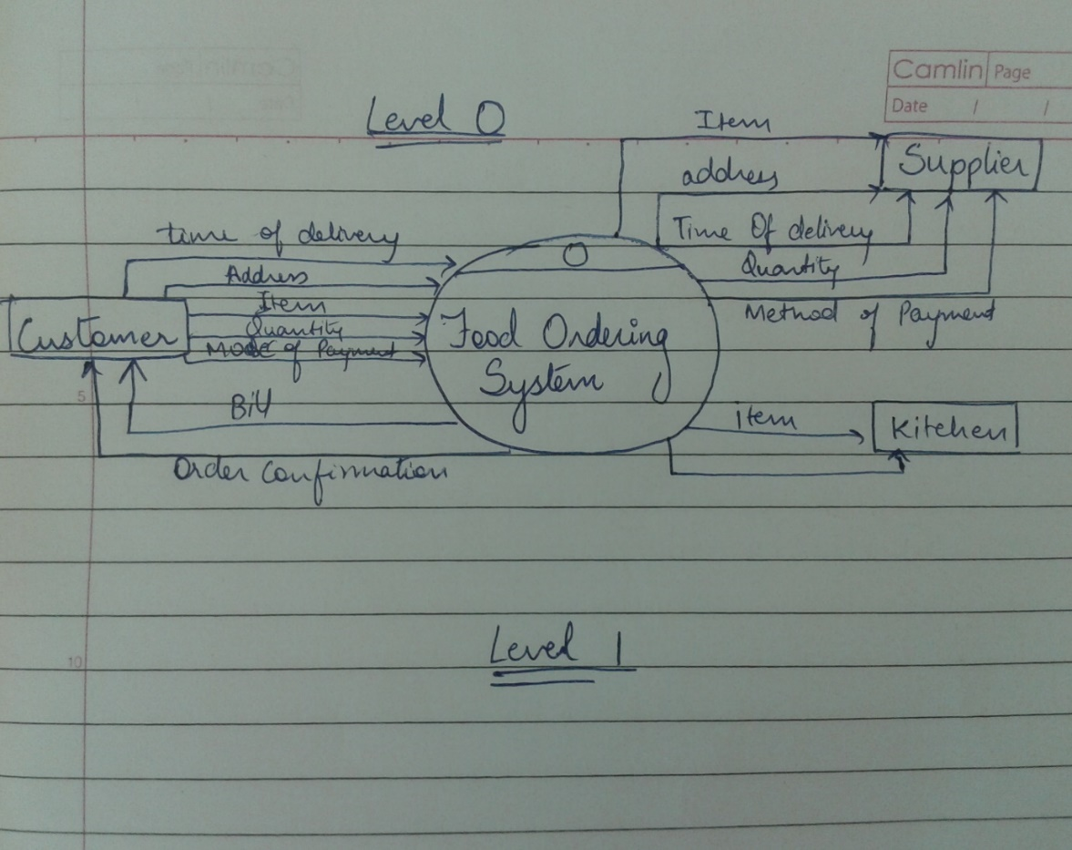 Data flow diagrams (level 0 and level 1):

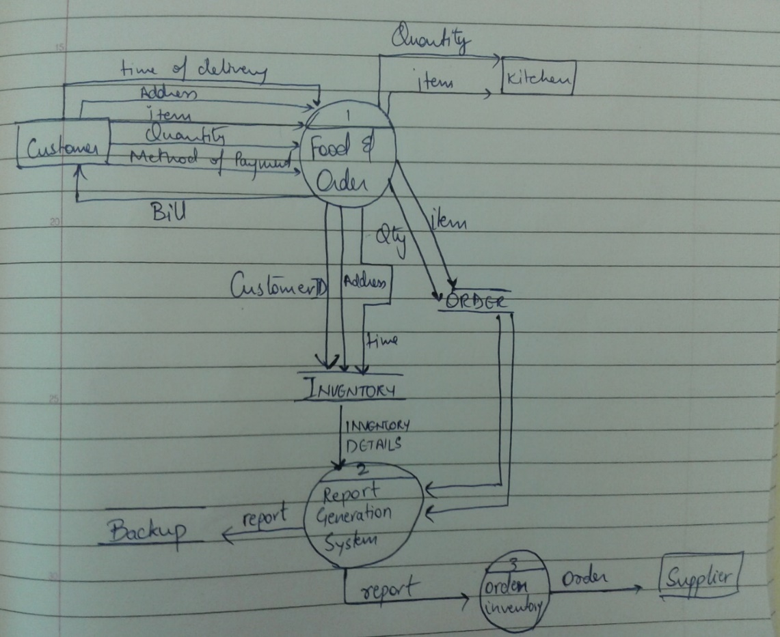

**APPLICATION SCREENS**

FIG1. THE COVER SCREEN

FIG1. COVER SCREEN

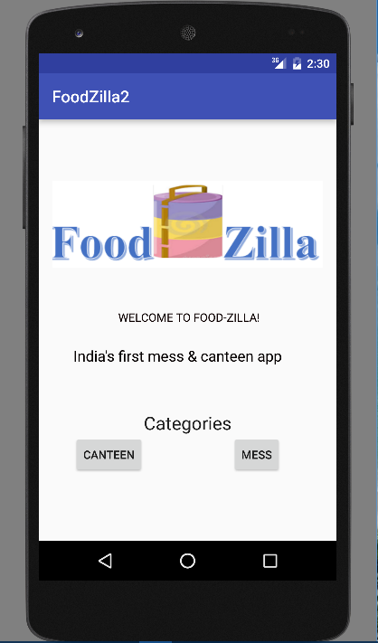

FIG2 AND 3. THE LIST OF MESS AND CANTEENS

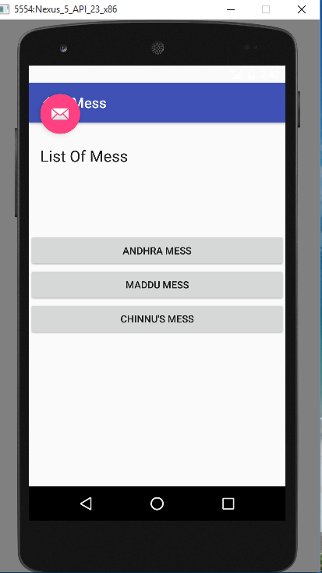

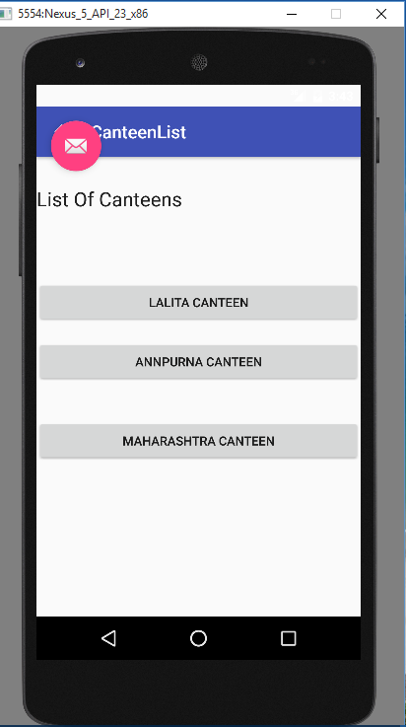

FIG 4 AND 5. ADDRESS OF MESS AND CANTEENS

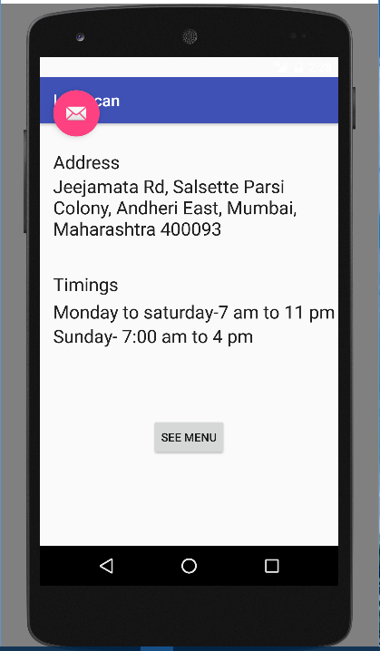 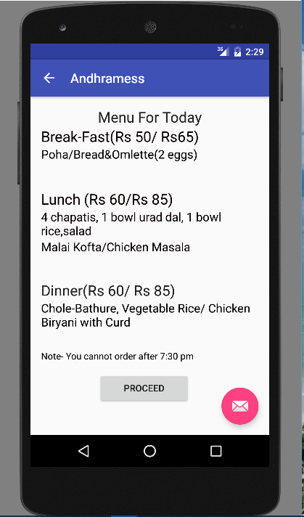

FIG 6. TIMINGS OF CANTEEN

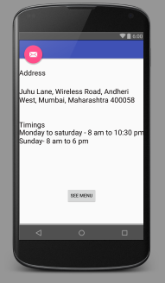

FIG 7 AND 8. MENU OF CANTEEN

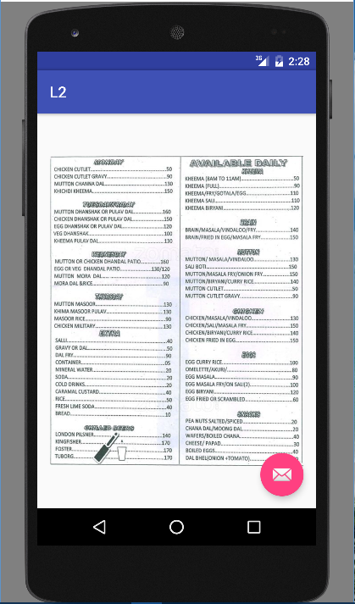 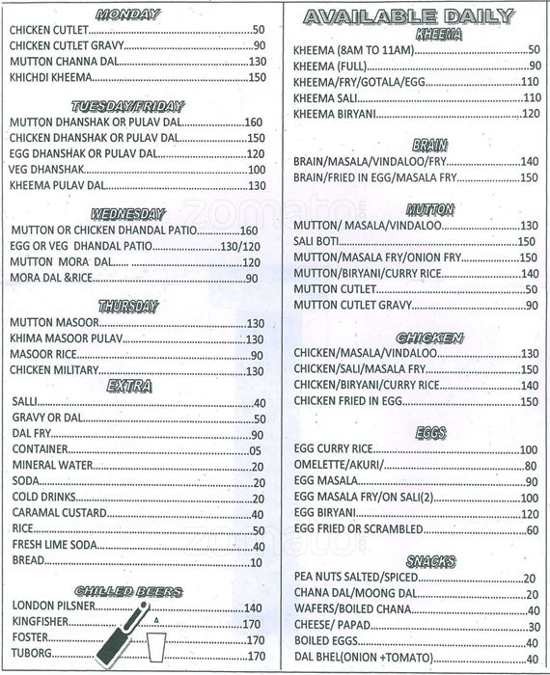

FIG 9 AND 10. MENU OF MESS

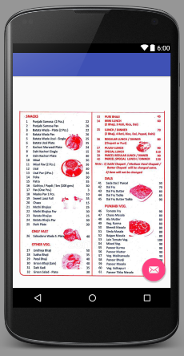 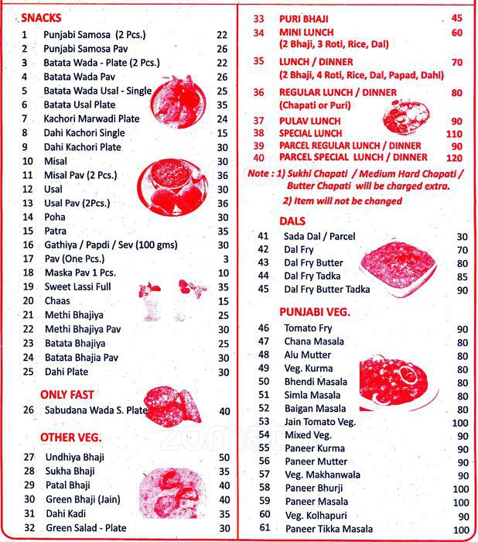

FIG 11. FINAL SCREEN FOR USER CREDENTIALS

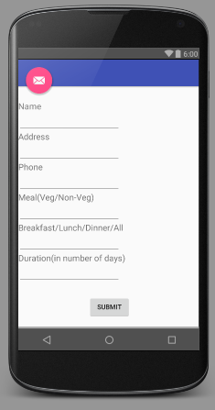

**SCOPE OF IMPROVEMENT**

* We can add GPS to the application to give idea to customer about location of mess and canteen.
* Enable the delivery executive with live GPS tracking to track the order.
* Live SMS updates on the status of the order.
* Generation of OTPs for order confirmation.
* Enable online transactions, e-wallet services.

**CONCLUSION**

->The app is yet to be taken online.

-> User database is yet to be created.

-> Filters are not added to the event.

-> More categories can be added to the event types.

**REFERENCES**

1. Videos provided in course
2. [www.youtube.com](http://www.youtube.com)
3. developer.android.com
4. [www.google.com](http://www.google.com)
5. ibuild**app**.com
6. ww.codeschool.com